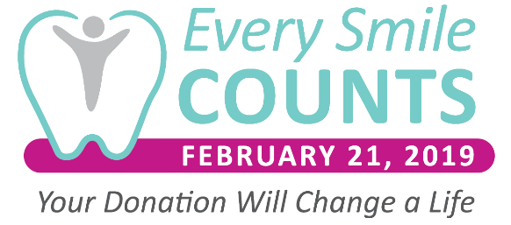
Sample Communications

Blog
Headline:
On February 21, 2019 – Every Smile Counts

For the third annual Every Smile Counts Day, the dental community will rally together to raise money benefitting Dental Lifeline Network (DLN). <Company Name> has pledged to donate to DLN on February 21, 2019 and many other companies are doing the same.

You can help too!

Dental community members are encouraged to donate in recognition of Every Smile Counts Day. The money raised will help provide dental treatment for individuals with disabilities, those who are elderly or medically fragile through DLN’s Donated Dental Services (DDS) program. Every dollar raised will generate nearly $9 in care to those who need it most. Hundreds of DDS patients will receive treatment as a result of Every Smile Counts Day fundraising efforts!

To learn more visit: www.EverySmileCountsDay.org

Website Banner
Headline: Every Smile Counts Day

February 21, 2019 is the third annual Every Smile Counts Day. We have pledged to donate to Dental Lifeline Network in recognition of this important day! You can help by joining us in donating to DLN on the 21st as well. Let’s work together to raise more funds for individuals with disabilities, those who are elderly or medically fragile and have no access to dental care.
<button link to www.EverySmileCountsDay.org>

Facebook

February 21, 2019 is the third annual Every Smile Counts Day! On this day, we’ll donate a portion of our national sales to Dental Lifeline Network (DLN).

You can help too! Donate alongside <company name> and other dental community members on February 21. By doing so, DLN will be able to serve more people in need. Because every smile – and every person – counts. #EverySmileCountsDay #SupportDLN

LinkedIn

Thousands of people lack access to desperately needed dental treatment. Every Smile Counts Day is a day that brings the dental community together to raise funds for those most in need. We are proud to support this remarkable organization.

On February 21, 2019, we’ll donate to Dental Lifeline Network.

You can help too! Plan to make a donation alongside <company name> on February 21. By doing so, DLN will be able to serve more people in need. Because every smile – and every person – counts. www.EverySmileCountsDay.org for more information.

#EverySmileCountsDay #SupportDLN

Twitter

We’re participating in Every Smile Counts Day to help more individuals get access to desperately needed dental care. Learn more at www.EverySmileCountsDay.org #SupportDLN #EverySmileCountsDay

