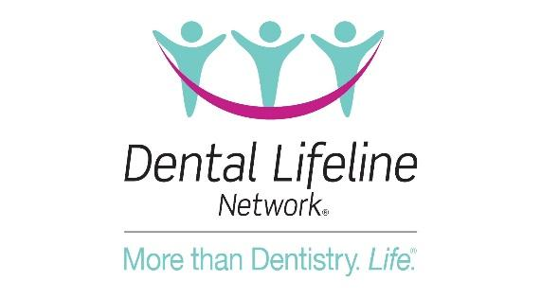

FOR IMMEDIATE RELEASE

Contact: Clair Diones
VP Marketing and Communications
cdiones@DentalLifeline.org
720.287.6186

Dental Lifeline Network Seeks Dentists Nationwide to Volunteer
With Over 7,000 Vulnerable Patients in Need, ADA President Dr. Cesar Sabates Asks Dentists to See at Least One Patient a Year
[DENVER, Colo., May 23, 2022] – Dental Lifeline Networks Donated Dental Services (DDS) program provides comprehensive donated dental treatment to vulnerable individuals with disabilities or who are elderly or medically fragile. Since its launch in 1985, DDS has provided over $500 million in donated dental therapies, impacting the lives of more than 166,000 vulnerable individuals.
With more than 7,000 patients currently on the national DDS waitlist, ADA President Dr. Cesar Sabates asked dentists nationwide to volunteer to see at least one patient a year.
“Our impact as dentists goes far beyond what we might consider all in a day’s work. Imagine what patients feel when they leave our care,” said Dr. Sabates. “When they are able to live without pain, enjoy a meal, and smile with confidence, we have made an improvement in a fellow human being’s quality of life. And that is the true work of a dentist.”
“DDS screens patients, coordinates appointments and completes the paperwork,” said Lynda Ricketson, Chief Executive Officer of Dental Lifeline Network. “It has never been easier to impact your community as a dentist. We hope that the message from Dr. Sabates will inspire more dentists to volunteer for our program and help more patients in critical need.”
To learn more about DLN, get involved, or explore programs in your state, visit DentalLifeline.org. To view Dr. Sabates’ call for dentist volunteers, visit https://youtu.be/t17dKJYPMbE.
About Dental Lifeline Network: Dental Lifeline Network (DLN) is a strategic partner of the American Dental Association whose mission is to improve the oral health of people with disabilities or who are elderly or medically fragile and have no other way to get help. DLN accomplishes its mission by developing and coordinating collaborative relationships that provide essential resources for direct-service programs, especially charitable care.
###

