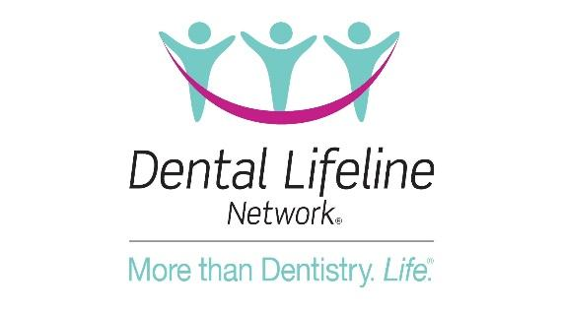

FOR IMMEDIATE RELEASE

Contact: NAME
TITLE
EMAIL
PHONE NUMBER
Dental Lifeline Network Seeks Dentists Nationwide to Volunteer
With Over 6,000 Vulnerable Patients in Need, DLN Volunteer, Dr. Lindsay Compton, Encourages Dentists Nationwide to Volunteer
[DENVER, Colo., March 9, 2023] – Dental Lifeline Networks Donated Dental Services (DDS) program provides comprehensive donated dental treatment to vulnerable individuals with disabilities or who are elderly or medically fragile. Since its launch in 1985, DDS has provided over $500 million in donated dental treatment, impacting the lives of more than 167,000 vulnerable individuals.
With more than 6,000 patients currently on the waitlist, DDS volunteer and Colorado Dental Association President, Dr. Lindsay Compton, encourages dentists nationwide to volunteer to see at least one patient a year.
“The mission of Dental Lifeline Network is so important and does so much good in the lives of individuals in need,” said Dr. Compton.
“DDS screens patients, coordinates appointments and completes the paperwork,” said Lynda Ricketson, Chief Executive Officer of Dental Lifeline Network. “It has never been easier to impact your community as a dentist.”
To learn more about DLN, get involved, or explore programs in your state, visit DentalLifeline.org. To view Dr. Compton’s call for dentist volunteers, visit https://bit.ly/3IRX7xX .
About Dental Lifeline Network: Dental Lifeline Network is a national charitable organization whose mission is to change the lives of America’s most vulnerable adults through their coordinated system of care. DLN accomplishes its mission by developing and coordinating collaborative relationships that provide essential resources for direct-service programs, especially charitable care.
###

